Day13 Revisit

CRUD Operations.

Performing CRUD operation in MySQL Workbench (GUI Mode)

Everything will happen with the click of buttons (No need to remember SQL Query syntax)

C – Create/Insert Operation [Create Query or insert query ]\

R – Read Operation [Full Read/Partial Read or Conditional Read]

Full Read will give list of records (List of Objects, List of Employees, List of Staffs – Collection is needed to handle the output)

Partial Read – Return either a single or few records of the table

U – Update Operation [Full Update & Partial Update] Update query

D – Delete Operation [Full delete (deleting group of records based on condition) , Partial Delete (deleting a single row with id) & whole delete(deleting all records without where clause)]

ACID – Atomicity Consistency Isolation Durability

Normalization – Is performed to reduce data redundancy [Avoiding duplicate data]

1NF – First Normal Form (A Table needs to have a primary key, no repeating groups and atomic columns)

2NF – Second Normal Form (No partial dependency on key column)

3NF – Third Normal Form (No transitive dependencies)

Constraints – Integrity Constraints

1. Primary Key (PK)
2. Foreign Key (FK)
3. Unique (UQ)
4. Not Null (NN)
5. Check (CK)
6. Default
7. Auto Increment (AI)

Joins (Combining data from two or more tables)

1. Left Join
2. Right Join
3. Inner Join
4. Outer Join
5. Self join

<https://www.w3schools.com/mysql/mysql_join.asp>

<https://www.javatpoint.com/mysql-join>

Orders table

Order_id (PK) customer_id (FK) oreder_date order_amount

100 2 25-Sep-2021 4000

101 10 17-Mar-2022 500

102 52 12-Dec-2021 700

Customers Table

Customer_id(pk) customer_name Address Phone

1 ABC Texas 9878768789

2 XYZ Canada 8765678766

10 MNO India 9878678756

52 LOP SL 8798675432

SELECT Orders.OrderID, Customers.CustomerName, Orders.OrderDate  
FROM Orders  
INNER JOIN Customers ON Orders.CustomerID=Customers.CustomerID;

Join will happen with the help of common column_name (primary & foreign key) only

Index columns will be sorted by default. Index columns are used to find data, sort it, fetch it easily.

CRUD operation

Create table user_table (id int AUTO_INCREMENT, username varchar(45) NOT NULL, password varchar(20) NOT NULL, email varchar(50), status int(1), primary key(id) );

Insert into user_table (username, password, email, status) values (“test123”, “test123”,[test@gmail.com](mailto:test@gmail.com)”, 1);

Select * from user_table; /* full read */

Select * from user_table where id = 1; /* partial read or selective read or read with where clause */

Update user_table SET username=”test1”, password=”test1” where id=2;

Delete from user_table; /* whole delete – Delete all records of the table */

Delete from user_table where id=5; /* delete only one record */

Executed Queries

Create table user_table (id int AUTO_INCREMENT, username varchar(45) NOT NULL, password varchar(20) NOT NULL, email varchar(50), status int(1), primary key(id) );

Insert into user_table (username, password, email, status) values ("aaa123", "bbb123","aaa123@gmail.com", 1);

select * from user_table;

select * from user_table where id>1;

select * from user_table where username like 'a%';

Update user_table SET username="test1", password="test1" where id=2;

Delete from user_table; /* whole delete – Delete all records of the table */

Delete from user_table where id=5; /* delete only one record */

SELECT * FROM my_schema.employee;

INSERT INTO `my_schema`.`employee` (`id`,`first_name`,`last_name`,`email`,`phone`)

VALUES (100,"test","data","test@gmail.com",9823457645);

UPDATE `my_schema`.`employee` SET `first_name` = "<{first_name: }>", `last_name` = "<{last_name: }>",`email` = "<{email: }>", `phone` = 9878675645

WHERE `id` = 5;

UPDATE `my_schema`.`employee` SET `first_name` = "test1", `last_name` = "data1",`email` = "test1@gmail.com", `phone` = 1002003000

WHERE `id` = 100;

/* Full read or complete read operation */ /* use ctrl+Enter key to execute the current line query only */

select * from employee;

/* Partial read operation*/

select * from employee where id>4;

Maven – Maven is a Project Management Tool for JAVA.

What Maven will do?

* It manages all the dependency of Java application
* It can manage life cycle of application development (Development, Testing, deploying, building)
* Building – Converting from .java to .class (Source code to byte code convertion)
* Installing – Install all the dependencies of the Java project
* Test – Execute Unit test codes of Java Application
* Clean – Clears the target folder of Maven project
* Helps to create different types of java project

Back bone of Maven is POM.xml

POM – Project Object Model

Every maven project will have two important details to uniquely identify the project.

1. Groupid (package name – all smallcase)
2. Artifactid (name of the project)
3. Additionally it will contain version number, to differentiate between various versions

How to Create a Maven Project (Each maven project will have POM.xml file which will be created automatically)

POM – Project Object Model

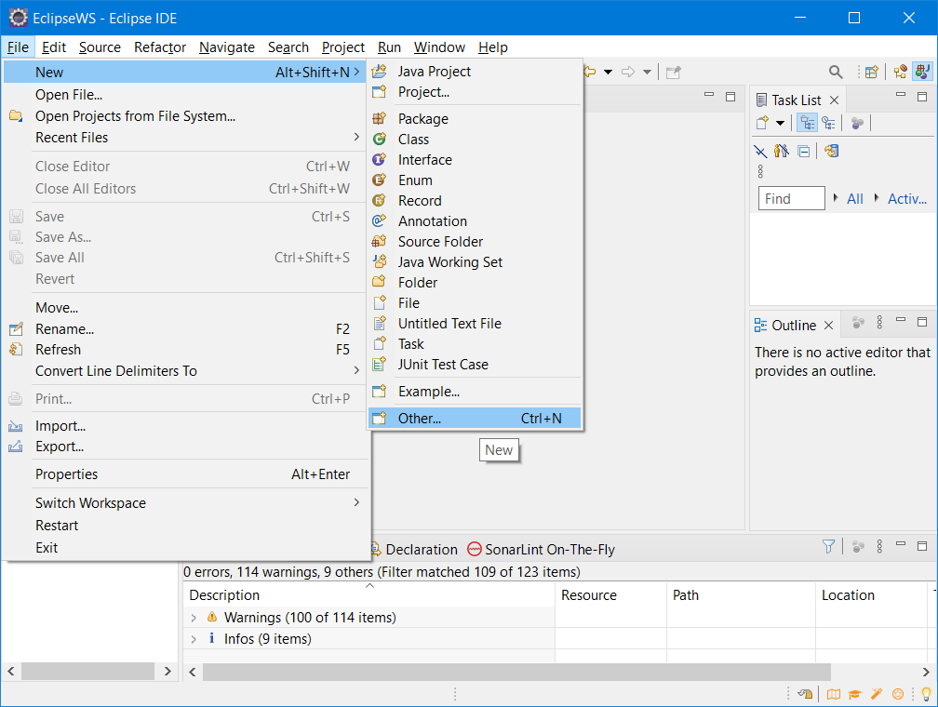

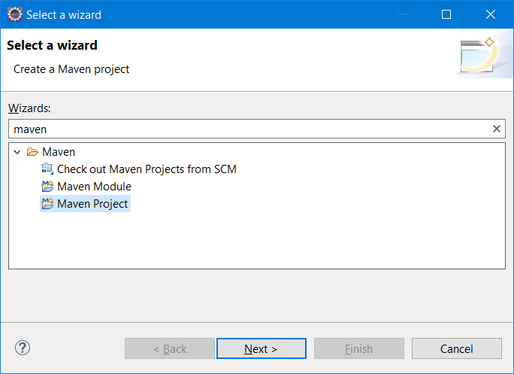

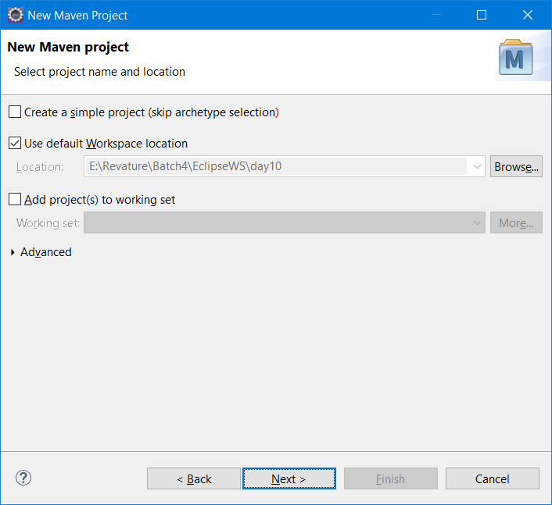

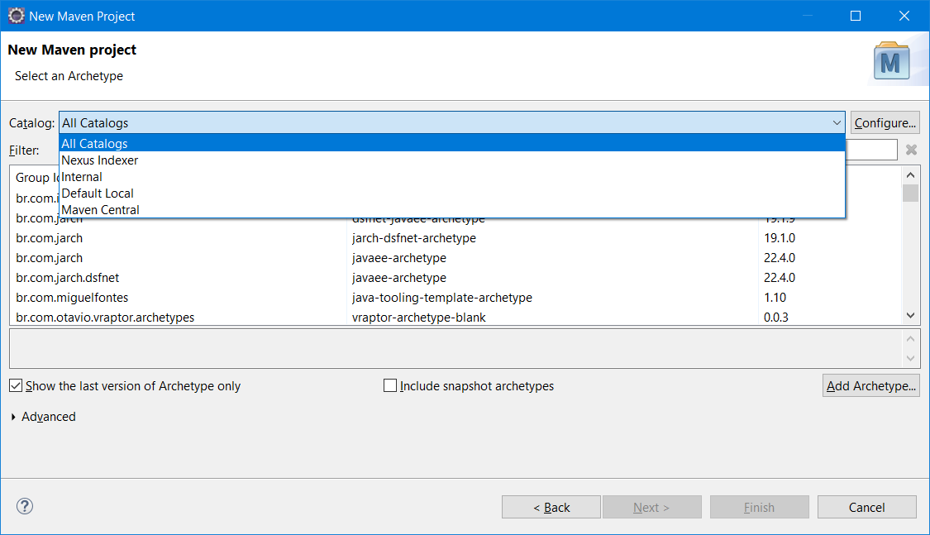

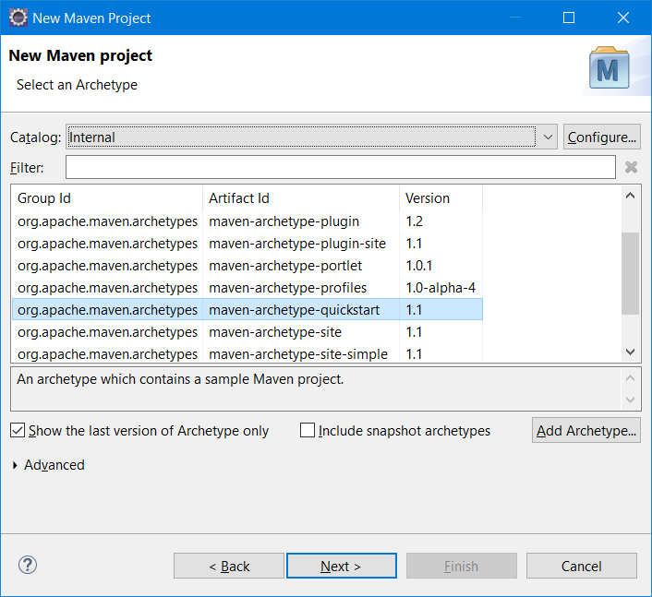

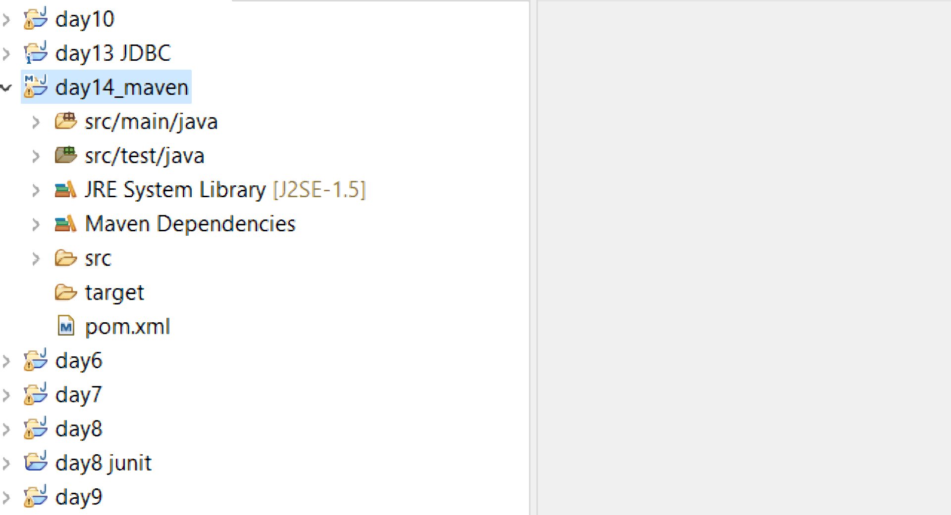

Maven projects will have src folder as input folder, target folder as output folder

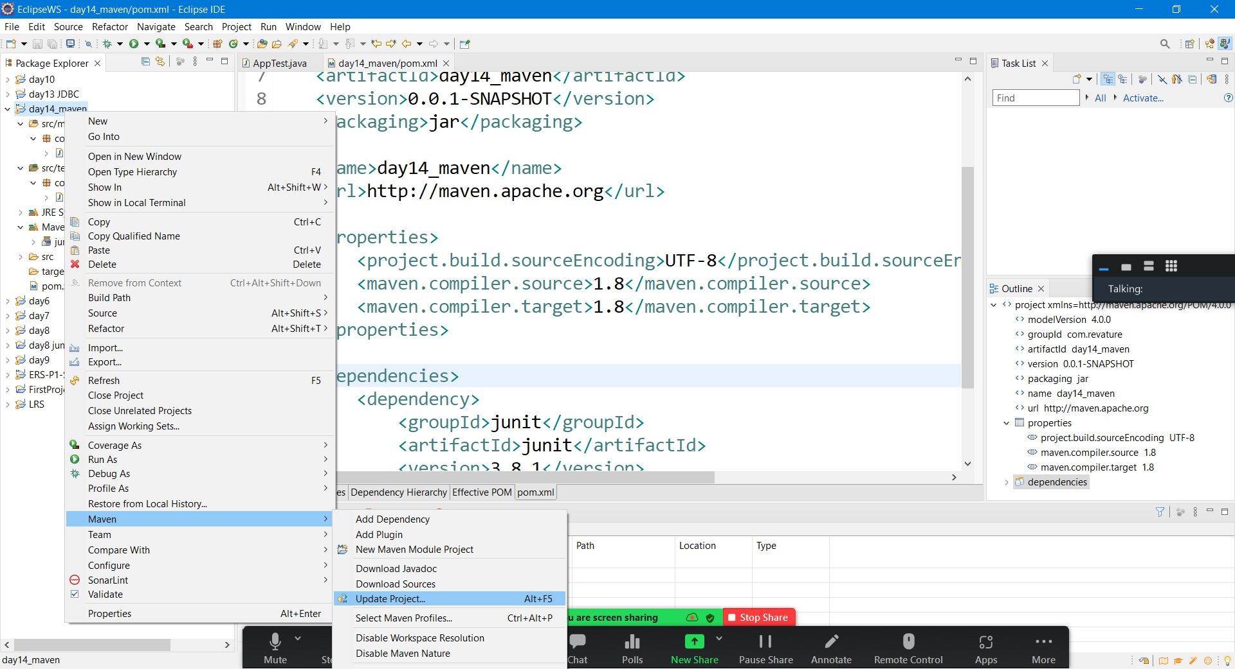

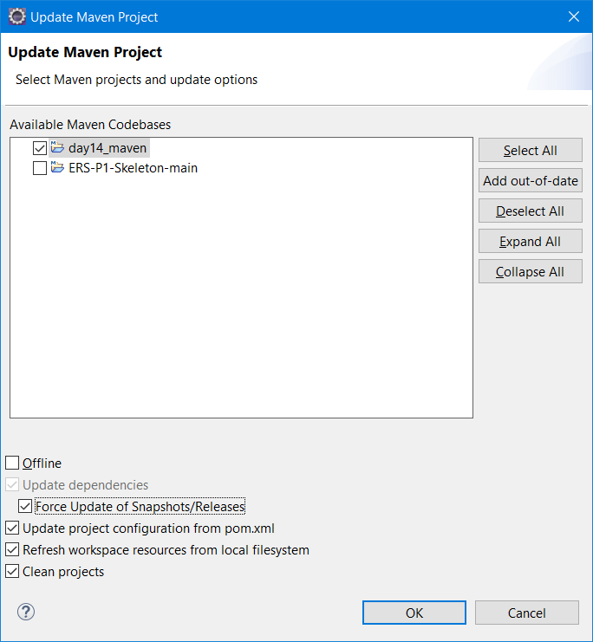

Maven can be accessed using command prompt also.

List of Maven commands (All maven commands will start with “mvn” )

1. mvn clean - Cleans the output (target) folder
2. mvn install – installs all the project dependencies
3. mvn package – Convert multiple files to a single jar/war file
4. mvn test – Will execute all unit test
5. mvn build -will convert all .java file to .class file (Source code to byte code conversion)

Download Maven from official site

<https://maven.apache.org/download.cgi>

[apache-maven-3.8.5-bin.zip](https://dlcdn.apache.org/maven/maven-3/3.8.5/binaries/apache-maven-3.8.5-bin.zip)

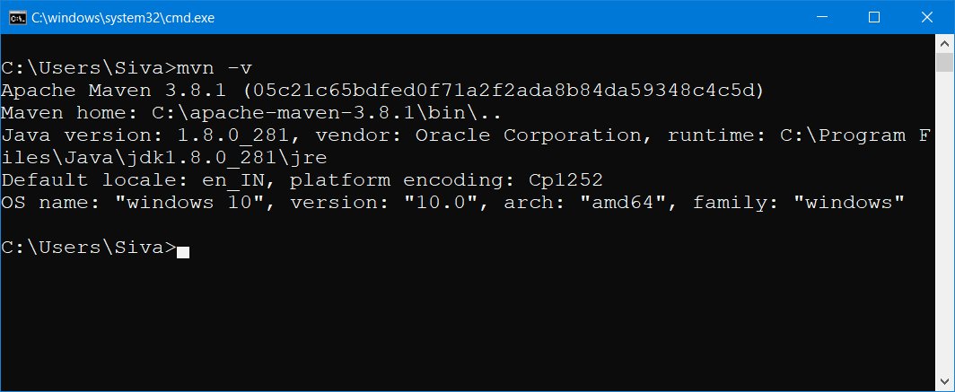

Need to add M2_HOME in environment variable

M2_HOME = C:\apache-maven-3.8.1

Path = %path%;%M2_HOME%\bin

Mac Users

Download tar.gz file from the official site

After extracting run this command

$ tar -xvf apache-maven-3.8.5-bin.tar.gz

export M2_HOME="/Users/pankaj/Downloads/apache-maven-3.6.3"

PATH="${M2_HOME}/bin:${PATH}"

export PATH

.m2 folder will be automatically created while accessing maven or running maven commands in command prompt.

Location of .m2 folder (Hidden folder)

For Windows: C:\Users\syska\.m2

Local Repository location : C:\Users\syska\.m2\repository

Central Repository or cloud repository : <https://mvnrepository.com/> or <https://search.maven.org/>

JDBC – Java Database Connectivity